Packet Tracer - Documenting the Network

1. Topology

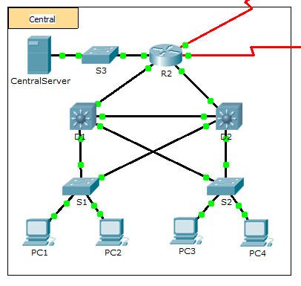

1. Background

In this activity, your job is to document the addressing scheme and connections used in the Central portion of the network. You must use a variety of commands to gather the required information.

**Note**: The user EXEC password is **cisco**. The privileged EXEC password is **class**.

1. Requirements

* Access the command line of the various devices in Central.
* Use commands to gather the information required in the **Addressing Scheme and Device Connection Documentation** table.
* If you do not remember the necessary commands, you can use the IOS built-in help system.
* If you still need additional hints, refer to the **Hints** page. In Packet Tracer, click the right arrow (>) on the bottom right side of the instruction window. If you have a printed version of the instructions, the **Hints** page is the last page.

1. Addressing Scheme and Device Connection Documentation

|  |  |  |  |
| --- | --- | --- | --- |
| Device Name | Interface | Address | Subnet Mask |
|
| R2 | G0/0 |  |  |
| G0/1 |  |  |
| G0/2 |  |  |
| S0/0/0 | 64.100.100.1 | 255.255.255.252 |
| S0/0/1.1 | 64.100.200.2 | 255.255.255.252 |
| S3 | VLAN 1 | 10.10.10.254 | 255.255.255.0 |
| F0/1 | N/A | N/A |
| G0/1 | N/A | N/A |
| CentralServer | NIC |  |  |
| D1 | VLAN2 | 10.2.0.1 | 255.255.255.0 |
| G0/1 |  |  |
| G0/2 |  |  |
| F0/23 | N/A | N/A |
| F0/24 | N/A | N/A |
| S1 | VLAN 2 | 10.2.0.2 | 255.255.255.0 |
| F0/23 | N/A | N/A |
| G0/1 | N/A | N/A |
| D2 | F0/23 | N/A | N/A |
| F0/24 |  |  |
| G0/1 |  |  |
| G0/2 |  |  |
| S2 | VLAN 1 | 10.3.0.2 | 255.255.255.0 |
| F0/23 | N/A | N/A |
| G0/1 | N/A | N/A |

1. Hints

Use the following commands to gather the information you need to document the network:

show ip interface brief

show interfaces

show running-config

ipconfig